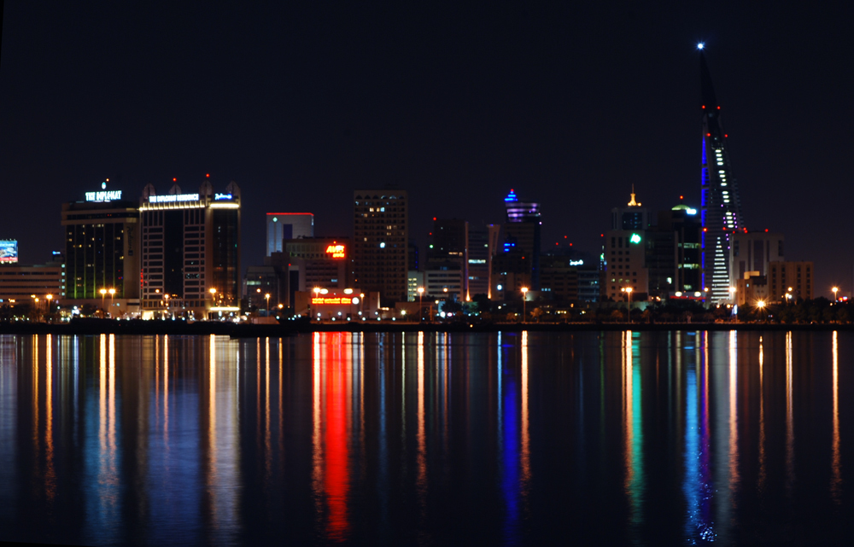
Manama Oldest new City
Living on the island of ancients and pottery
The history is glory and the present is development
Development came by days, the people got more exhort
Every single being worked to his country betterment
Tears on my cheeks, burn my heart country of pearls
Its summer clouds, soon it will be declared
The pearls of my eyes, be aware of the curls
Sun of peace will rise to start a new beginning
Summer clouds soon appears to new a season
The future of the island is now underpinning
The reborn of a new civilization
The creative designs of huge buildings arise
New developments made Bahrain more globalize

