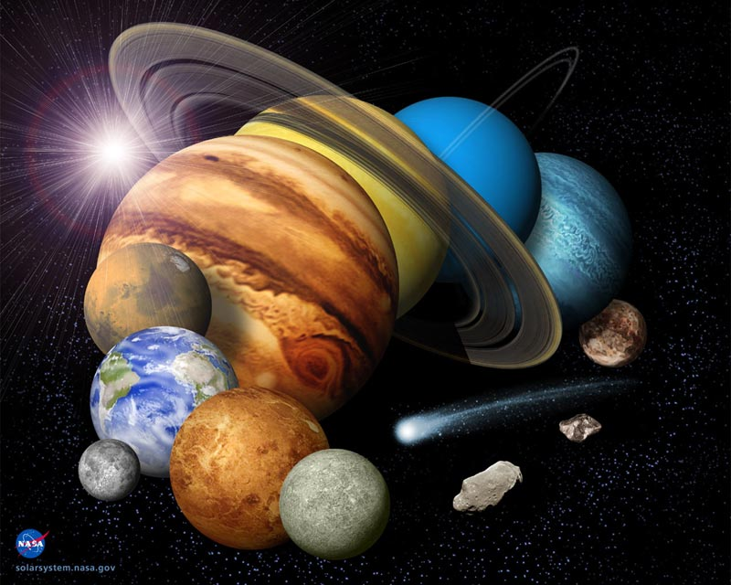
Earth’s Solar System
The home and shelter of beings is the earth
The cool world is like the beauty of a piece of art
Day by day, night by night a new birth
It shelters the vanguard and the snow hart
The land of covered with green carpet called turf
Beings are part of earth and this is the start

Every spot on earth is like a shelter for every creature
The globe shelters its children in its warm hug
The world teaches you lesson every day as a schoolteacher
On earth every being feels comfortable and snug
The whole globe stands together as one ranger
Earth is the life of the universe, it is luxe

The world is like a paradise for all creatures
Earth is like a diamond orbiting the universe
The earth is one of the mysterious teasers
All around the globe the beings are disperse
It cares about its kids; one of keenest keeners
This planet should get much more what it deserve

